The city is called a city of waterfalls due to a number of waterfalls in the rainy season. Khopoli is located at the base of the Sahyadri Mountains range on the banks of the Patalganga river. This place also has several waterfalls, parks and hill stations. Because of its natural environment and scenery, Khopoli is a major spot for tourist attractions. Khopoli is connected with metro cities like Mumbai and Pune by rail and road. Imagica Theme Park and Zenith waterfall are the key attraction of this place. Khopoli is surrounded by tourist places like Khandala and Lonavala. The place has proximity to railway stations and bus stands. Also, cabs and rickshaws are common means of transport in Khopoli.

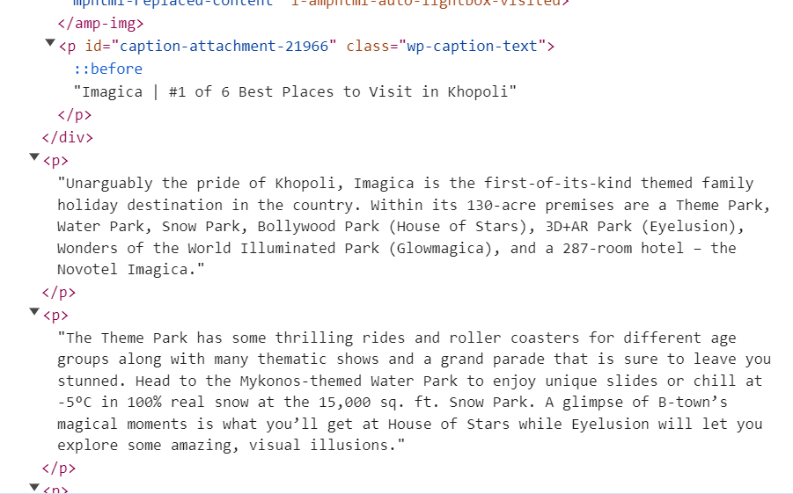

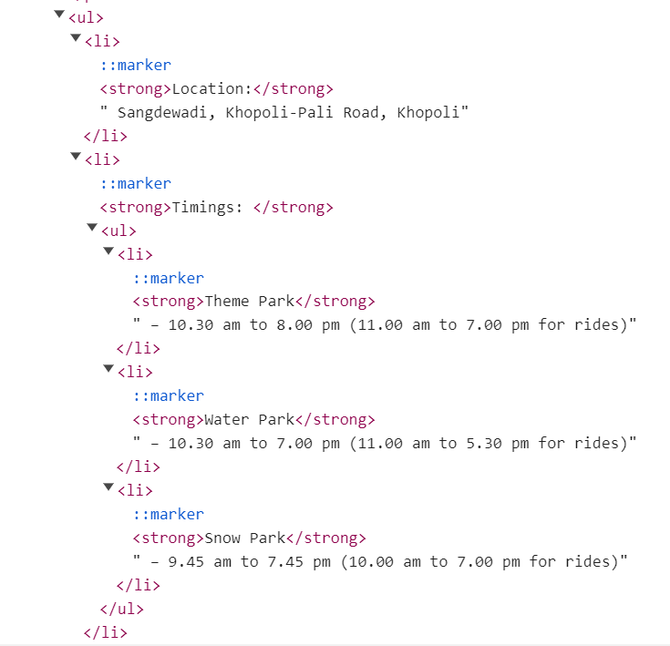

z

Khopoli is often regarded as Maharashtra’s hidden gem. However, it wasn’t until recently that this incredible location emerged as a vibrant holiday spot, offering a perfect mix of adventure, culture, and tranquility.

With attractions ranging from the adrenaline-filled river rafting experience to the quiet, spiritual ambiance of ancient temples, [Khopoli](https://www.youtube.com/watch?v=S0cTn1C3zzk" \t "_blank) is a place where every visit brings a new discovery.

Today we are going to discuss 11 incredible things to do in Khopoli that will make your visit a truly enriching experience.

**1. Imagicaa Theme Park**

Imagicaa stands as one of the most sought-after places to visit in Khopoli, drawing families and thrill-seekers from across the state. This wonderful theme park, with its range of exciting rides catering to all age groups, ensures a day packed with joy and excitement.

From the dizzying spins of roller coasters to the charming attractions designed for the little ones, Imagicaa promises an unforgettable adventure for everyone.

Apart from its rides, Imagicaa also captivates its visitors with live entertainment and thematic festivities that bring stories to life. This among the park's many other attractions is what makes it a cornerstone among the places to visit in Khopoli.

**2. Gagangiri Maharaj Ashram**

As the name suggests, the Gagangiri Maharaj Ashram is a spiritual retreat, dedicated to the teachings of Gagangiri Maharaj. Found amidst the lush landscapes of Khopoli, the ashram provides a sanctuary for those seeking solace and inner peace.

The most important aspect of the ashram's environment is its simple architecture and natural beauty that encourages meditation and reflection. Additionally, the visitors here are invited to take part in the ashram's daily rituals and programs, with an attempt to foster a sense of community and spiritual well-being.

In a world where peace and silence are becoming increasingly rare, the ashram offers a much-needed break from the hassle, making it a great place to visit in Khopoli.

**3. Zenith Waterfall**

Another one of the most serene places to visit in Khopoli, the Zenith Waterfall is a natural spectacle that comes alive with the monsoon rains. This deeply hidden piece of nature offers a refreshing escape, where the falling water and the cool mist create an atmosphere that is perfect for rejuvenation and relaxation.

Just like many other Khopoli tourist places, the Zenith Waterfall is a nature-rich adventure through the landscapes of the Sahyadris, inviting adventurers and nature lovers alike.

With picnics by the waterfall, amidst the symphony of nature, the Zenith Waterfall is a testament to the natural wonders that Khopoli has to offer, making it a beloved Khopoli picnic spot.

Khopoli has a "fine oval shaped reservoir" and a temple of God [Mahadev](https://en.wikipedia.org/wiki/Shiva) as Vireshwar built by Nana Phadnavis. The reservoir is built of solid and strong black rock and is oval shaped. The circumference of the reservoir is about 1207 m and it covers an area of about 75000 sq m. The reservoir holds excellent water throughout the year. The reservoir has surrounding walls also built in stone and are of a width of about 1.5 m to 1.8 m. The reservoir has stone steps leading to the water. The temple is of a height of about 22.9 m m from the base to the top and the foundation measures 12.2 m x 6.1 m. Inside is the image of God Shiva. The Sabha [mandap](https://en.wikipedia.org/wiki/Mandap) measures about 6.1 m x 3.1 m. At the entrance of the temple is a [samadhi](https://en.wikipedia.org/wiki/Samadhi#As_mausoleum). A fair is held in honor of the temple deity on [Mahashivaratri](https://en.wikipedia.org/wiki/Mahasivaratri" \o "Mahasivaratri) day - [Maagha](https://en.wikipedia.org/wiki/Maagha" \o "Maagha) Vadya 13.[[1]](https://en.wikipedia.org/wiki/Khopoli#cite_note-KDZ-1)[[12]](https://en.wikipedia.org/wiki/Khopoli#cite_note-TDG-12)

The PAPCO Mill complex has a [Parashurama](https://en.wikipedia.org/wiki/Parashurama" \o "Parashurama) temple and [Fire](https://en.wikipedia.org/wiki/Fire) temple or [Agni](https://en.wikipedia.org/wiki/Agni) [Mandir](https://en.wikipedia.org/wiki/Mandir) which was built in 1971.[[36]](https://en.wikipedia.org/wiki/Khopoli#cite_note-36)[[37]](https://en.wikipedia.org/wiki/Khopoli#cite_note-37) The Gagangiri Maharaj Ashram is located in Khopoli, it is there that [Gagangiri Maharaj](https://en.wikipedia.org/wiki/Gagangiri_Maharaj" \o "Gagangiri Maharaj) died on 4 February 2008.[[38]](https://en.wikipedia.org/wiki/Khopoli#cite_note-38)

The Akhil Bharatha Ayyappa Seva Sangham, includes the Ayyappa Temple, in its list of [Ayyappa](https://en.wikipedia.org/wiki/Ayyappa" \o "Ayyappa) temples in India and abroad.[[39]](https://en.wikipedia.org/wiki/Khopoli#cite_note-39)

The major tourist attractions in the city include [Adlabs Imagica](https://en.wikipedia.org/wiki/Adlabs_Imagica" \o "Adlabs Imagica), which is India's largest theme park. Mahad Ganpati Temple, Zenith Waterfalls, and [Gangangiri](https://en.wikipedia.org/wiki/Gagangiri_Maharaj" \o "Gagangiri Maharaj) Maharaj Ashram [Lonavala](https://en.wikipedia.org/wiki/Lonavla) is just 8 km away from the city.

<div class="controls">

        <span class="vid-btn active" data-src="vid-1.1.mp4"></span>

        <span class="vid-btn" data-src="vid-2.mp4"></span>

        <span class="vid-btn" data-src="vid-3.mp4"></span>

        <span class="vid-btn" data-src="\_\_\_\_\_"></span>

        <span class="vid-btn" data-src="vid-5.mp4"></span>

    </div>

<div class="video-container">

        <video src="vid-1.1.mp4" id="video-slider" loop autoplay muted></video>

    </div>